Submission Template

Entity Relationship Diagram

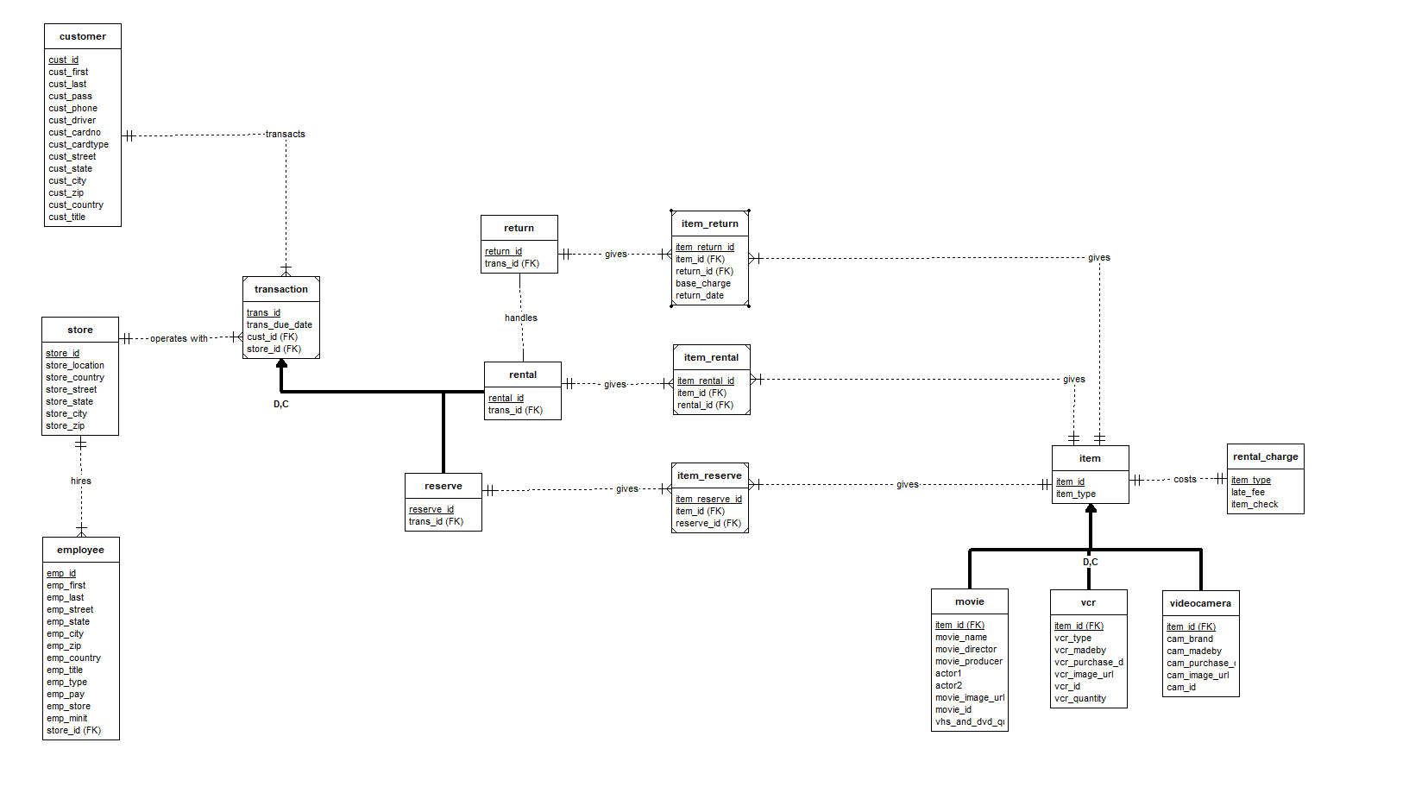

Database Diagram

|  |  |  |  |  |  |
| --- | --- | --- | --- | --- | --- |
| Table | Purpose | Field | Data Type | Primary Key | Foreign Key |
| Customer | Record all customer info | cust_id  cust_first  cust_last  cust_pass  cust_phone  cust_driver  cust_cardno  cust_cardtype  cust_country  cust_state  cust_city  cust_zip  cust_street  cust_title | int  nvarchar(50)  nvarchar(50)  nvarchar(50)  nchar(10)  nvarchar(50)  nchar(16)  nvarchar(50)  nvarchar(50)  nchar(2)  nvarchar(50)  nchar(5)  nvarchar(50)  nvarchar(50) | cust_id | NIL |
| Store | Record store info | store_id  store_country  store_state  store_city  store_street  store_zip | int  nvarchar(255)  nchar(2)  nvarchar(50)  nvarchar(50)  nchar(5) | store_id | NIL |
| Employee | Record all employee info | emp_id  emp_first  emp_last  emp_country  emp_state  emp_city  emp_zip  emp_street  emp_type  emp_pay  emp_title  emp_store | int  nvarchar(50)  nvarchar(50)  nvarchar(50)  nchar(2)  nvarchar(50)  nchar(5)  nvarchar(50)  nvarchar(50)  decimal(6,2)  nvarchar(50)  int | emp_id | emp_store references Store (store_id) |
| Transaction | Store transaction info | trans_id  trans_date  trans_cust  trans_store | int  datetime  int  int | trans_id | trans_cust references Customer (cust_id)  trans_store references Store (store_id) |
| Rental | Store transaction info pertaining to rentals | rental_id  transaction_id | int  int | rental_id | transaction_id references Transaction  (trans_id) |
| Reserve | Stores transaction info pertaining to reserving of items | reserve_id  transaction_id | int  int | reserve_id | transaction_id references Transaction  (trans_id) |
| Return | Stores rental info pertaining to return of items | return_id  rentalid | int  int | return_id | rentalid references Rental (rental_id) |
| item_return | Junction table for storing item info and return info | item_return_id  base_charge  return_date  itemid  returnid | int  decimal(4,2)  datetime  int  int | item_return_id | itemid references Item  (item_id)  returnid references Return  (return_id) |
| item_rental | Junction table for storing item info and rental info | item_rental_id  itemid  rentalid | int  int  int | item_rental_id | itemid references Item  (item_id)  rentalid references Rental  (rental_id) |

|  |  |  |  |  |  |
| --- | --- | --- | --- | --- | --- |
| item_reserve | Junction table for storing item info and reserve info | item_reserve_id  itemid  reserveid | int  int  int | item_reserve_id | itemid references Item  (item_id)  reserveid references Reserve  (reserve_id) |
| Item | Storing referenced item info and item type | item_id  item_type | int  nvarchar(50) | item_id | item_type references rental_charge (item_type) |
| Movie | Stores movie information and quantity | itemid  movie_name  movie_producer  actor1  actor2  movie_image_url  vhs_and_dvd_quantity  moveie_id | int  nvarchar(250)  nvarchar(50)  nvarchar(50)  nvarchar(50)  nvarchar(50)  int  int | itemid | itemid references Item (item_id) |
| VCR | Stores VCR information and quantity | itemid  vcr_type  vcr_brand  vcr_madeby  vcr_purchase_date  vcr_image_url  vcr_quantity  vcr_id | int  nvarchar(50)  nvarchar(50)  nvarchar(50)  datetime  nvarchar(50)  int  int | itemid | itemid references Item (item_id) |
| videocamera | Stores video camera information and quantity | itemid  cam_brand  cam_madeby  cam_purchase_date  cam_image_url  cam_quantity  cam_id | int  nvarchar(50)  nvarchar(50)  datetime  nvarchar(50)  int  int | itemid | itemid references Item (item_id) |
| rental_charge | Stores late charge info based on item type | item_type  item_check  late_fee | nvarchar(50)  nvarchar(50)  decimal(4,2) | item_type | NIL |

Queries

|  |  |
| --- | --- |
| Query 1 | Query 1 Results |
|  |  |
| Query 2 i | Query 2i results |
|  |  |

|  |  |
| --- | --- |
| Query 2 ii | Query 2 ii Results |
|  |  |
| Query 3 | Query 3 Results |
|  |  |

|  |  |
| --- | --- |
| Query 4 | Query 4 Results |
|  |  |
| Query 5 | Query 5 Results |
|  |  |

|  |  |
| --- | --- |
| Query 6 | Query 6 Results |
|  |  |